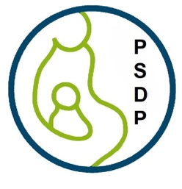

**Advocacy Appeal: Restore Funding for the Pediatric Scientist Development Program**

## **The Write Time is Now**

For four decades, the Pediatric Scientist Development Program (PSDP) has been a cornerstone in training physician-scientists dedicated to improving children’s health. Since 1987, this program has supported over 270 early-career pediatricians, providing the time, mentorship, and resources they need to pursue groundbreaking research. From life-saving treatments for cystic fibrosis to innovations in childhood cancer therapies, PSDP-funded research has transformed pediatric medicine and given hope to countless families.

Yet, on March 21, 2025, the federal grant that has sustained PSDP for over 35 years was abruptly terminated with no opportunity for appeal. This decision, justified based on recruitment strategies for diverse scholars, essential elements that were both required and recommended by peer reviewers, will now dismantle a vital training pipeline. Without PSDP, we risk losing the next generation of physician-scientists who develop cures and advance treatments for childhood diseases.

We need you. As a parent, caregiver, pediatrician, or advocate for child health, you can help reinstate funding for PSDP and protect the future of pediatric research. Join us in a nationwide letter writing campaign. ***Note that you do not have to be an adult or a U.S. citizen to express your views to members of Congress.***

**It’s time to use your OUTSIDE voice.**

**How You Can Help**

1. Write to Your Legislators

Legislators need to hear real-life stories to understand the impact of these cuts. Families, physicians, and researchers have a front row seat to share their own compelling stories. Use the template below to send an email or letter to your representatives in Congress. Include the PSDP infographic below.

1. Organize a Letter-Writing Campaign from Children

Children who have benefited from pediatric research have a unique perspective and voice to share their stories. Whether they are thriving because of treatments developed by PSDP graduates or hoping for future medical breakthroughs, their voices are powerful and serve as a testament to why physicians-scientists embark on this life-changing work.

1. Spread the Word

We need to engage everyone who has been touched by scientific research. Share this call to action with your own networks. Post on social media, in parent groups, in PTA emails, and in advocacy organizations newsletters. Amplify this message far and wide so everyone in your circles can join this important fight.

**Follow These Steps to Reach Members of Congress**

Write to ***Louisiana Senator Bill Cassidy***, [Chair of HELP Committee](https://www.help.senate.gov/chair/newsroom) (Health, Education, Labor & Pensions)

* Email: <https://www.cassidy.senate.gov/contact/get-in-touch/>
* Mailing Address:

455 Dirksen Senate Office Building  
Washington, D.C. 20510

**Write to Your Senators and Representative**

* [Find who represents you](https://ballotpedia.org/Who_represents_me).
* Our goal is to flood offices with letters and postcards. You can follow up on your mail with a phone call to the U.S. Capitol Switchboard and an operator can connect you directly with your member of Congress. 202.224.3121.

**Tips**

* Keep your letter to one page.
* Include the infographic below with your letter.
* Avoid jargon.
* Make it personal.
* Include your name, address, and contact information.
* Note that these are your own views rather than those of your employer.
* Use personal email address, not work email.

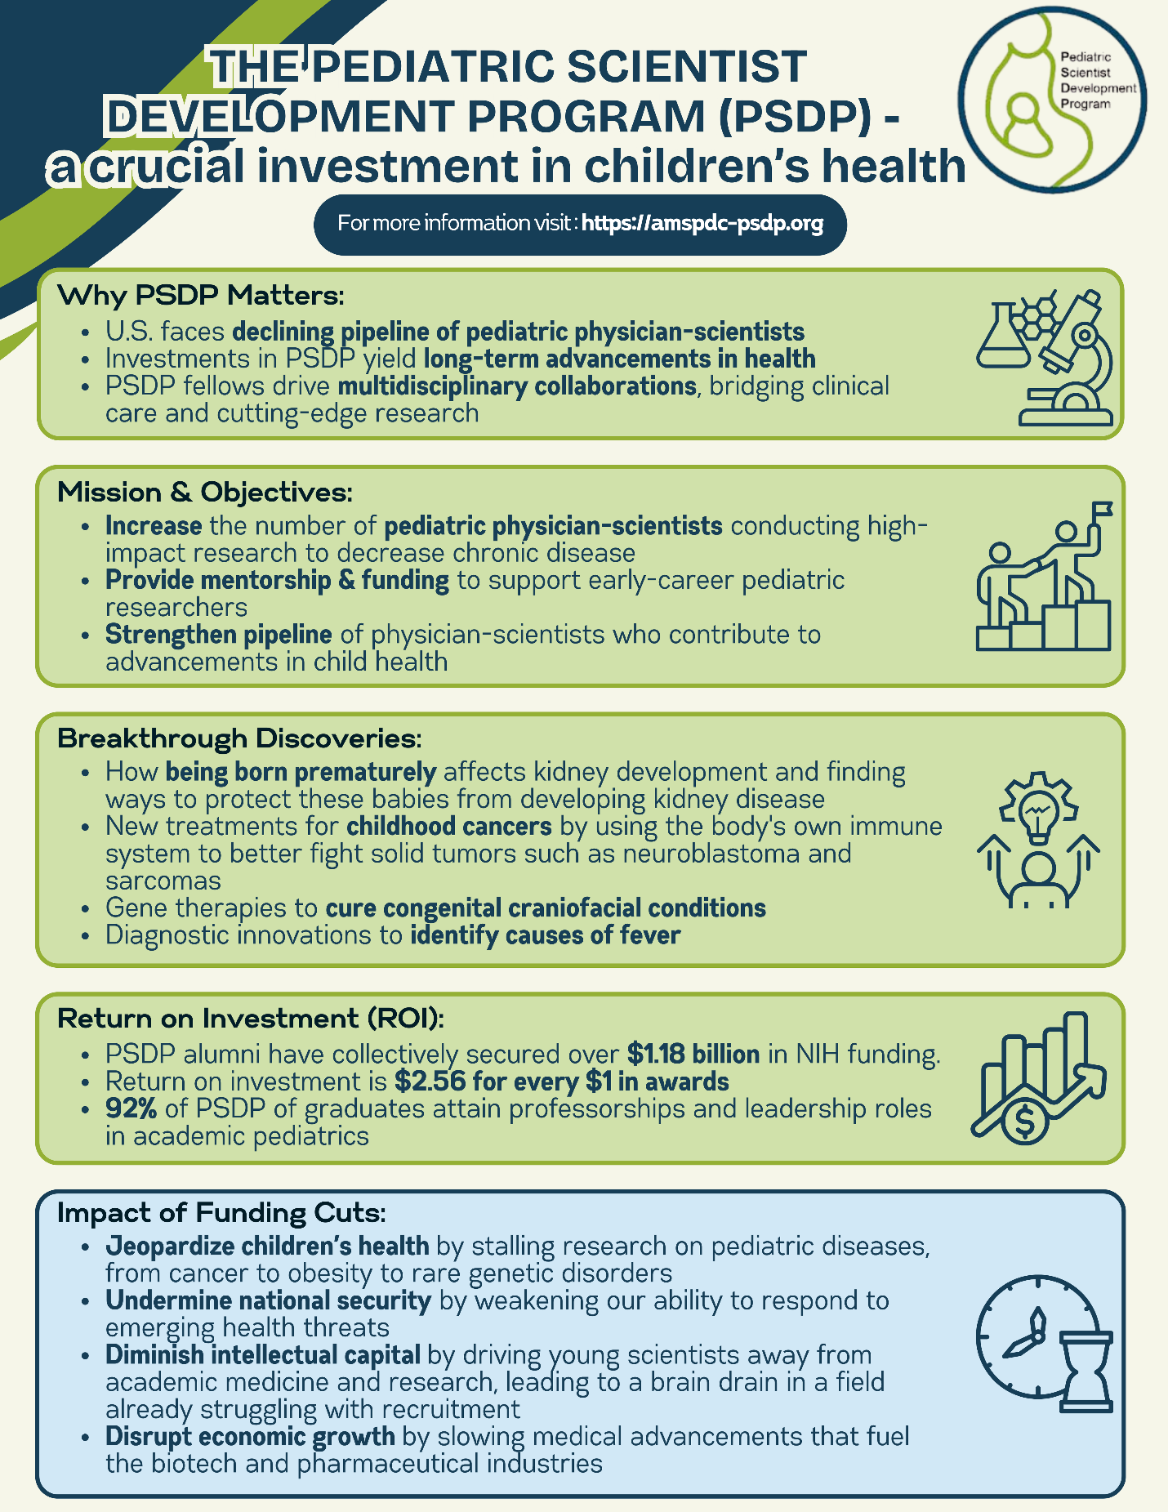

**Writing a letter to Congress has some unique advantages over postcards or emails**:

1. More Detailed & Persuasive – A letter allows for a deeper explanation of the issue, including personal stories and data that strengthen your argument.
2. Shows Commitment – A physical letter requires effort, making it more impactful than an email or social media post. Lawmakers take well-written, personalized letters more seriously.
3. More Likely to Reach Policy Staff – Letters often get routed to legislative aides, who brief lawmakers on key issues. A compelling letter can influence policy discussions.
4. Formal & Professional – Letters demonstrate seriousness and professionalism, making them effective for advocacy groups, professionals, and coalitions.
5. Can Include Supporting Materials – Unlike a postcard, you can include fact sheets or photos to reinforce your message.

**Correct Address Format for Letters**

Senate:

The Honorable __________________________  
United States Senate  
Washington, D.C. 20510

Dear Senator ___________________________,

House:

The Honorable __________________________  
United States House of Representatives  
Washington, D.C. 20515

Dear Representative ______________________,

**Sample Letter for Legislators** **([Perfect stamps for this](https://store.usps.com/store/product/thank-you-healthcare-community-stamps-S_485804)!)** 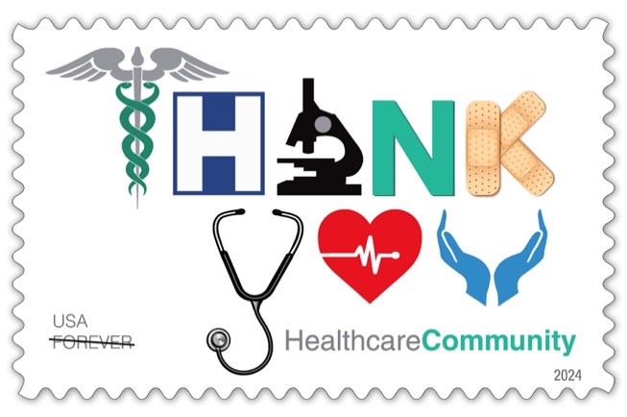

Subject: Urgent Action Needed—Restore Funding for Pediatric Research

Dear [Senator/Representative Name],

I am writing to express my fear and concern over the abrupt termination of funding for the Pediatric Scientist Development Program (PSDP), a program that has trained over 270 physician-scientists and fueled life-saving discoveries in pediatric cancer and chronic diseases like cystic fibrosis. I urge you to advocate for the immediate reinstatement of PSDP funding. Our children deserve the best medical minds focused on their health. Without this critical program, we risk losing a generation of pediatric researchers whose work could shape the future of children’s health. And most importantly, we are jeopardizing the health of innocent children who just want a chance to grow up.

[***Add a few sentences of your personal story here***]

On March 21, 2025, the NICHD terminated PSDP’s long-standing K12 grant, citing diversity recruitment strategies that were both required and recommended by peer reviewers. Incidentally, Dr. Diana Bianchi, director of NICHD, was also just terminated this week. This threatens the already fragile pipeline of pediatrician-scientists, undermining efforts to advance treatments for children with rare and complex diseases.

Please stand with families, researchers, and child health advocates in restoring this essential program. I look forward to your response and to seeing your leadership on this issue.

Sincerely,

[Your Name]

[Your Address]

[Your Contact Information – email and phone number]

**Sample Letter from Children**

Dear [Senator/Representative Name],

My name is [Child’s Name], and I am [Age] years old. I was born with [Condition, e.g., cystic fibrosis, a rare disease, a heart condition], and thanks to research, I have been able to [share a personal outcome, e.g., play soccer, go to school, enjoy time with my family].

The doctors and scientists who help kids like me need programs like PSDP to learn how to find cures and treatments. But this program just lost its funding, and that makes me sad and worried for other kids who still need help.

Please bring back PSDP so more doctors can find ways to help kids like me grow up to live happy and healthy lives.

Thank you for listening.

Sincerely,

[Child’s Name]

**Writing a postcard to Congress is easier and can be effective for a few key reasons:**

1. Short & Impactful – Postcards force brevity, making messages clearer and quicker to read. Lawmakers and staff receive thousands of messages; a concise postcard stands out.
2. No Envelope Hassle – Unlike letters, postcards don’t need to be opened and go through rigorous security screening, so they get noticed and read faster.
3. Personal Touch – A handwritten note on a postcard feels more personal and compelling than an email or form letter.
4. Easy for Children to Participate – Children can write or draw on postcards, making them a powerful advocacy tool.
5. Visible Advocacy – Delivering a stack of postcards or seeing a pile of postcards on a legislator’s desk is a striking visual reminder of public outcry.

**Postcards to Print (**Specs for [First-Class Mail postcard rate](https://www.google.com/search?cs=0&sca_esv=baa11aa09dcbea86&q=First-Class+Mail+postcard+rate&sa=X&ved=2ahUKEwj_0-_0nb2MAxUwTDABHQFrHxYQxccNegQIAhAB&mstk=AUtExfDDOfPKnHjQaEZEvBTI0nVtTtKLJL4OMq2N3_2NLh1pD_ZakSUDQXnTMEVdXgrX_13fBi0m8LF-XYAHaAo-ftTrieUWMfFMM_fFjfZ0T4hApyxzt0OXBJlytMdMloDP6iY&csui=3)):

Shape - Rectangular

Minimum Dimensions:

* Height: 3-1/2 inches
* Length: 5 inches
* Thickness: 0.007 inches

Maximum Dimensions (for First-Class Mail postcard rate):

* Height: 4-1/4 inches
* Length: 6 inches
* Thickness: 0.016 inches

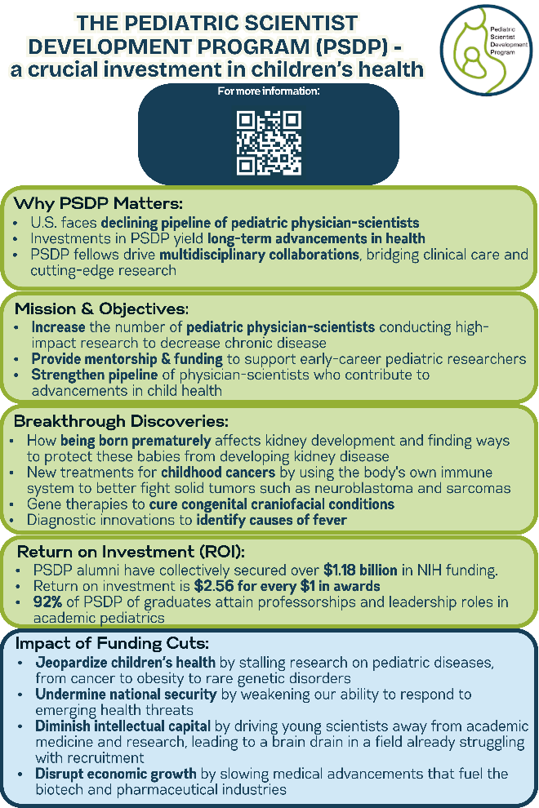

**Postcard for Legislators** **([Postcard stamps here](https://store.usps.com/store/stamps/0-56/_/N-ekvkdt))**

Dear [Senator/Representative Name],

The Pediatric Scientist Development Program (PSDP) has trained doctors to find cures for children’s diseases since 1987. On March 21, 2025, its funding was abruptly cut, threatening future breakthroughs in child health.

Please act now to reinstate PSDP funding and protect pediatric research. Thank you for standing with children and families.

Sincerely,

[Your Name]

[Your Address]

**Postcard from Children**

Dear [Senator/Representative Name],

My name is [Child’s Name], and I am [Age] years old. Thanks to research, I can [personal outcome, e.g., run, play, go to school]. But PSDP, the program that trains doctors to help kids like me, just lost its funding. Please bring it back so more kids can get better and grow up!

Thank you!

[Child’s Name and Age]

**Share on Social Media**

* Post one of the images below and ask your followers and networks to join our letter writing campaign.
* Post a photo of you writing a letter/postcard and invite others to join you.

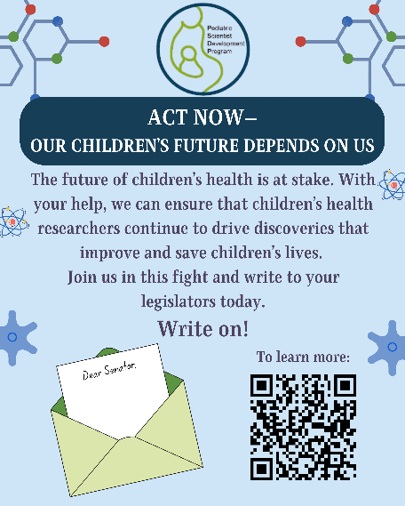 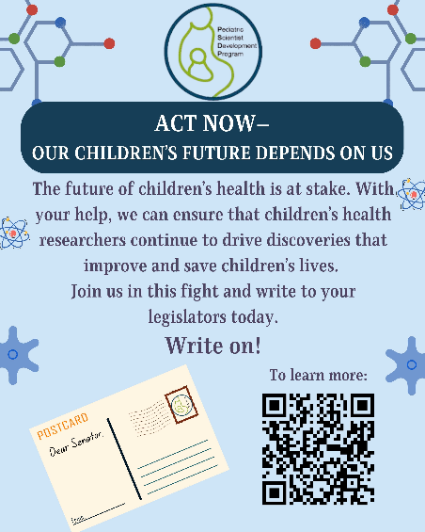

**Sample Social Media Post**

It’s time to use our OUTSIDE VOICES to save pediatric research!

For nearly 40 years, the Pediatric Scientist Development Program (PSDP) has trained physician-scientists who discover life-saving treatments for children facing cancer and chronic diseases. But on March 21, 2025, its funding was abruptly cut, threatening future breakthroughs in children’s health.

💙 Meet Emma: Born with a rare genetic disorder, Emma wasn’t expected to live past infancy. Thanks to research led by PSDP-trained doctors, she’s now a thriving 8-year-old who loves soccer and science class. Without PSDP, discoveries like the one that saved Emma’s life might be stalled or worse, never happen again.

📢 Take Action:

✍️ Write to Congress—tell them to restore PSDP funding

📬 Join our postcard campaign—let kids share their stories

📣 Spread the word—use #SavePSDP to raise awareness on social media

Children like Emma deserve a future. Let’s make sure pediatric research has one too. #ProtectPediatricResearch #SavePSDP

**Hashtags**

#ProtectPediatricResearch #SavePSDP #EraOfTheChild

**Act Now -- Our Children’s Future Depends on Us**

The future of pediatric medicine is at stake. With your help, we can ensure that physician-scientists continue to drive discoveries that improve and save children’s lives. Join us in this fight and write to your legislators today.

**Write on!**